Performance Evaluation of Effective Microorganisms in septic tank: study by Novozymes

# Background of the study:

A study focused on the utilization of effective microorganism additives in septic tanks and determining their effectiveness in reducing the sludge accumulation rate (SAR) was conducted jointly by CDD India and Novozymes South Asia Pvt. Ltd. The entire research study was designed and conducted in two phases, the phase 1 was conducted at a lab scale and Phase 2 in the field (2 stages) in four septic tanks identified in Bhagamandala, Karnataka.

# Methodology:

## Lab scale study and Set up:

The lab scale study was conducted in ten FRP tanks of 50 L capacity, fabricated and installed near the Beedi Workers Colony, located nearby CDD India office, Kengeri, Bangalore. Sewage of 15 litres was fed into the tanks from the septic tanks located at the local community. For this study, different effective microorganisms (Septic Tank Additives) available in the market along with Novozymes effective microorganisms were taken and dosed in different tanks to analyse the effect on sludge volume reduction and effluent quality. The phase 1 – lab study was conducted between the period of August 2021 to November 2021.

Figure 1: Lab scale setup for Phase 1

## Field Study and set up:

Field study was designed to evaluate the performance of effective microorganism selected from the Lab Scale studies to be tested in the real time on-ground conditions. For this study, four septic tanks were selected in Bhagamandala, Coorg, Karnataka which consist of two households and two commercial/non-household spaces (one public toilet and one temple toilet).

During Stage I of the phase 2, all four septic tanks were desludged completely. HH1 alone was added with effective microorganism and other three septic tanks were maintained as controls representing real time on ground conditions. In stage II, effective microorganism was added to the rest of the three septic tanks and HH 1 was not dosed. Instead HH 1 was desludged in stage II to eliminate the residual effect of effective microorganism added in stage I of phase 2. Table 1 below illustrates the dimension and background information on each septic tank.

Table 1: Details of Septic tanks evaluated in phase 2

|  |  |  |  |  |
| --- | --- | --- | --- | --- |
| **Parameters** | **Public toilet** | **Behind temple** | **House hold 1** | **House hold 2** |
| **Dimension (m)** | 5.3x 2.1 x 1.5 | 5.3 x 2 x 1.40 | 2.5 x 1.4 x 1.3 | 2.5 x 1.4 x 1.3 |
| **Volume (m3)** | 22.5 | 14.9 | 4.6 | 4.6 |
| **Users/day** | 30-40 users | 30 users | 6 users | 4 users |
| **Wastewater** | Blackwater | Sewage | Black water | Black water |

Phase 2 was conducted between the period of April 2022 to July 2023. During the phase 2, the dosage of effective microorganism was fixed based on the volume of septic tank and the type of infrastructure (Households and commercial toilets).

## Parameters monitored for analysis:

Sludge height variations, effluent quality and solid content of sludge for all four septic tanks were monitored in both lab and field study. Sludge height measurements were used to determine the Sludge accumulation rate (SAR) for the respective septic tanks (with and without effective microorganism). The estimated SAR values were compared against the SAR value mentioned in IS Code 2470, which is 76.7 liter/person/year for septic tanks.

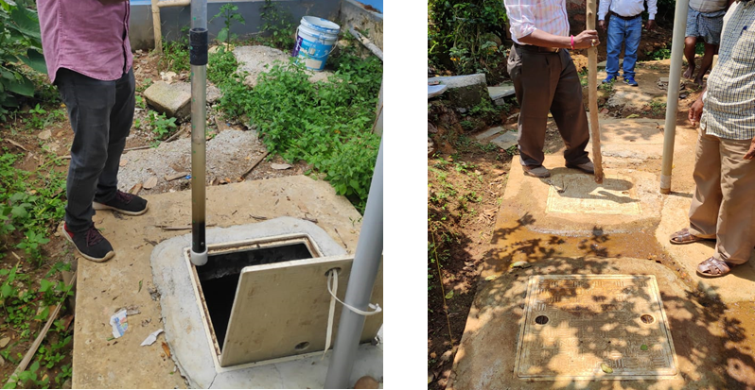

Figure 2: Sludge height measurement using the Core Sampler

# Findings:

## Lab scale study: Phase I

Among the eight effective microorganism cultures evaluated in phase I, Septic Aid Power by Novozymes was identified as the best-performing culture with maximum sludge volume reduction of 60-70% which was higher compared with the control sample (without any additives) of 30-40% and maximum of 50-60% of organic content reduction against the control sample performance of 25-30% (VS:TS ratio of 0.45 with additives and 0.56 without additives) in the residual sludge at the end of study period.

## Findings from field study: Phase 2

Combined SAR values for the public toilet was estimated to be 65.7 liter/person/year without effective microorganism addition (stage I) and 73 liter/person/year with effective microorganism addition (stage II). In this septic tank, no significant effect of effective microorganism was observed. This might be due to insufficient dosage and frequency as high flush rate and high organic loading influenced the performance in a public toilet and the organic content reduction of only 20-25% was observed.

In case of the temple toilet septic tank, which was desludged in middle of the stage II study led to a temporary disruption and does not provide an accurate SAR value. After the disruption the study was conducted for three-month period, during which the SAR value of 40.2 liter/person/day was observed with the addition of effective microorganism. The SAR value observed in stage I without effective microorganism provided a value of 51.1 liter/person/year which was 33% lesser than the Standard IS code value.

In case of HH 1, the combined SAR value of 21.9 with effective microorganism – stage I) and 10.95 (without effective microorganism – stage II) liter/person/year was estimated. The possible explanations for this scenario might be due to the slower digestion rate and delayed priming period of microorganism culture which was suspected to be caused by unfavourable climatic condition (low temperature and monsoon interference). However, There was a significant reduction of 57% in SAR value with respect to IS code SAR value and achieved the organic content reduction of 25-30%.

In case of HH2, the combined SAR values for the HH 2 were estimated to be (without effective microorganism) 20.1 liter/person/year in stage I and in stage II (with effective microorganism) 10.22 liter/person/year. These are the lowest values observed during the stage II of the study period of six months for HH 2. It has been observed that, although the SAR values estimated for the septic tanks in the study are much lesser than that of the IS code, the SAR values with addition of effective microorganism and without effective microorganism were following quite similar trend. However, the organic content reduction of 35-45% was observed in both stages for HH2, which was the highest across the four septic tanks.

In order to understand the reason behind the reduction in SAR rates in Households, the rate of digestion has to be corelated. The ratio of VS to TS (VS:TS) indicate the rate of digestion the sludge has undergone in a septic tank, can give a good inference on whether SAR rates achieved are achieved by the digestion effect inducted by effective microorganism added. Household septic tanks showed better reduction in VS:TS ration compared to the public toilet and temple toilet septic tanks. The reason for poor reduction in public and temple toilet septic tanks were high flushing rate caused by high utilization, which causes sludge washout and led to short sludge retention time to undergo complete digestion.

Among the households, HH 2 showed a significant reduction in the VS/TS ratio with the effective microorganism addition compared to HH 1. During stage I, the ratio of VS to TS (VS:TS) was estimated to be 0.74 with the average total solids (TS) of 14,058 mg/L and with a volatile solids (VS) of 10,446 mg/L. While in the stage II with effective microorganism, the ratio of VS to TS was estimated to be 0.69 which is less than stage I, with the average TS of 13,407 mg/l and with VS of 9031 mg/l. The lower VS to TS ratio indicates the reduction in VS content due to anaerobic digestion which could be also be enhanced in Stage II with addition of Novozyme Bioproduct and also by the high ambient temperature (35 – 40-degree C) during the study period.

In HH 1 (with effective microorganism) during stage I VS:TS ratio was estimated to be 0.80 with the average total solids (TS) content in the sludge was 19,625 mg/L and with a volatile solids (VS) content of 15,596 mg/L. While in the Stage II (without Effective microorganisms), the ratio of VS to TS was estimated to be 0.68 which is less than Stage I with the average TS content in the sludge was 17,367 mg/l and with VS content of 11,919 mg/l. The lower VS to TS ratio indicates the reduction in VS content due to anaerobic digestion which could be enhanced in Stage II without addition of Novozyme Bioproduct by the high ambient temperature (35 – 40-degree C) during the study period.

# Summary:

In summary, the Sludge accumulation rates were found to be reducing in order of Public Toilet (highest) > Temple Toilet (higher) > HH 1 and 2(lowest) in the Stage I and 2 assessment, which were significantly lower than the benchmark value of 76.7 liter/person/year, as specified in IS Code 2470. Among all four septic tanks, HH 2 showed the lowest SAR values with HH 1 being the second lowest. The lower SAR values are attributed to the prolonging the desludging interval for the septic tanks (i.e. longer it takes for the sludge to fill in the septic tanks). The reduction in SAR are well supported by the reduction in VS:TS ratio, which indicates that the reduction in SAR are influenced by digestion of organic content in the sludge accumulated inside the septic tanks. However, it has to be noted that the reduction in SAR and VS:TS ratio were influenced by the factors like sludge washout and movement between chambers during the study period. In order to sustain the above results for household septic tanks, continuous and long-term addition of microbes is recommended.

Table 2: Comparison of SAR values across different studies and Literatures

|  |  |  |  |  |  |
| --- | --- | --- | --- | --- | --- |
| **Source** | **Condition** | **Septic Tank** | **Pits** | **Household Septic Tank** | **Commercial Septic Tank** |
| **CPHEEO** | Ideal |  | 67* |
| **Sircilla** | Ideal | 31.8* | 15.6* |
| **Devanahalli** | Ideal |  | 30.3* |
| **IS-code: 2470** | Ideal | 76.7* |  |
| **Novozyme** | With EM | | | 28.5* | 65.7* |
| Without EM | | | 36.5* | 73* |

***\*All values converted to l/p/year from m3/p/day (considering average values)***

# Limitations:

However, it's important to acknowledge certain limitations in this study. Several factors such as number of users, user behaviour, water consumption, sludge washouts and local climate conditions were identified to have impact on septic tank performance. This study was primarily focused on general observational data and did not extensively explore potential interactions between these above variables, which could have provided a more comprehensive understanding of their combined impact on Sludge accumulation rates in septic tanks.

The study also does not consider the economic aspects like cost of effective microorganism from the angle of long-term sustainability and affordability in the market.